

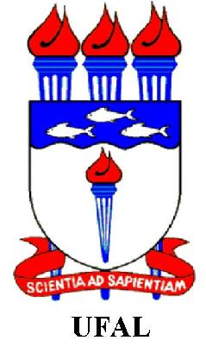

XV ESCUELA LATINOAMERICANA DE VERANO EN INVESTIGACION OPERATIVA (XV ELAVIO) - “The Operations Research as Science”,
Universidade Estadual do Ceará (UECE), Pacoti/CE-Brazil, August, 2nd-6th, 2010

LETTER OF INVITATION

Dear Mr(s) ,Nome,

The XV ELAVIO committee and ALIO, is proud to invite you to give a talk of
the following theme: “nome da palestra” as ALIO (Assiociación de Investigacion de Operaciones) - representing.

Your talk will be taken in one of the afternoons in the period of the school. The languages of the XV ELAVIO are: English, Portuguese and Spanish.

The payment of your air travel tickets between cidade (Pais) – Fortaleza (Brazil) – cidade (Pais) will be of your responsibility, and the school (ALIO) will pay for your transportation from Fortaleza to Pacoti/CE, hotel in Pacoti, and meal for the period of the school (August, 2nd to 6th). There will be no further payment for your coming. For attending the school, you still have to pay a contribution of US$ 50,00.

Please confirm soon your coming by sending us a copy of your presentation, as in the web page, and the travel ticket. It is important to book your stay in the hotel and bus.

With my best regards,



Marcos José Negreiros Gomes
Chair of the XV ELAVIO

